Mirfield Lodge  No 1102  Consecrated  1st June 1866  Grand Patron of the Grand Charity  Patron of the RMBI Festival 2017 | 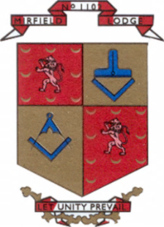 | Masonic Hall  14 King Street  MIRFIELD  WF14 8AW  Tel (01924) 493150

Name
Address

Dear ,
Personal free time has become a much-valued commodity, and everyone wants some of yours. After the difficulties and isolation of COVID, how you spend your free time and how you develop as a person possibly feels more important than ever before.
Freemasonry provides an unequalled opportunity for social interaction and personal development, all in a safe and fun environment. You may be right for Freemasonry, and we may be right for you and your family.
In addition to masonic meetings, we have an extensive social program throughout the year. This includes formal dinners and informal get-togethers, a group weekend away, and at Christmas, we have a carol concert and a children’s party.
My proposer into Freemasonry once said, “there are very few places where you can take your loved ones and know there will be no fighting or swearing, just a group of like-minded people enjoying themselves.” A rare thing in this world.
We are a local established lodge with more than 150 years of history, and we are looking for nice people who want to join us.
The enclosed leaflet will give you an idea of what we are about generally, and who can or cannot join. Please get in touch and arrange to meet us one evening at Mirfield, and we can talk it through. We can explain what Freemasonry is and perhaps, more importantly, what it is not.
There is no obligation to attend every meeting or social event, and work and family always come first. But Freemasonry is like life, you will only get out of it what you put in.
If you would like to discuss possibly joining our Lodge, please feel free to call me on 07767 765130 or email me at membership@mirfield1102.org
We look forward to hearing from you.

Membership Officer

